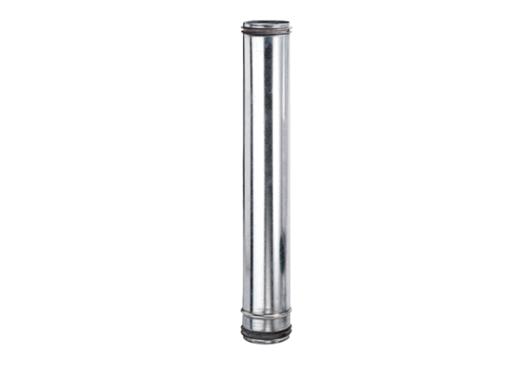Fire protection compensation element BA 160-0Packing unit: 1 pieceRange: B
Article number: 0093.1021Manufacturer: MAICO

