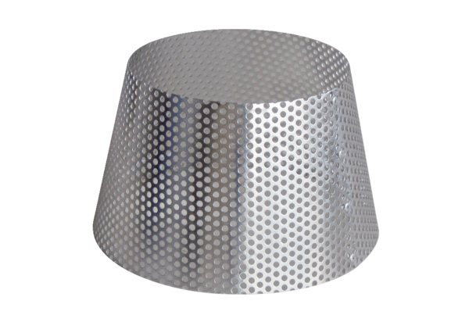Rain protection grille RG 125Packing unit: 1 pieceRange: B
Article number: 0151.0280Manufacturer: MAICO

