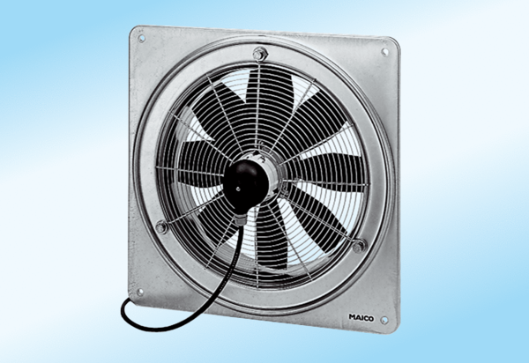Axial wall fan DZQ 40/4 A-ExPacking unit: 1 pieceRange: C
Article number: 0083.0776Manufacturer: MAICO

