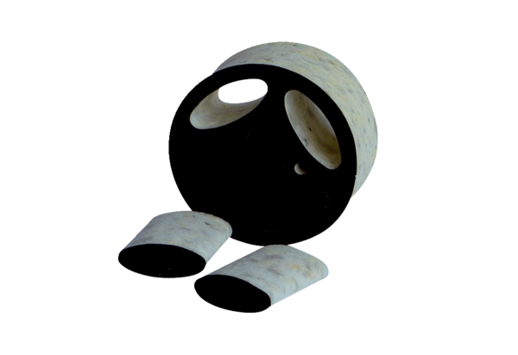Slide-in sound absorber SDE 8Packing unit: 1 pieceRange: C
Article number: 0044.0213Manufacturer: Jeven

