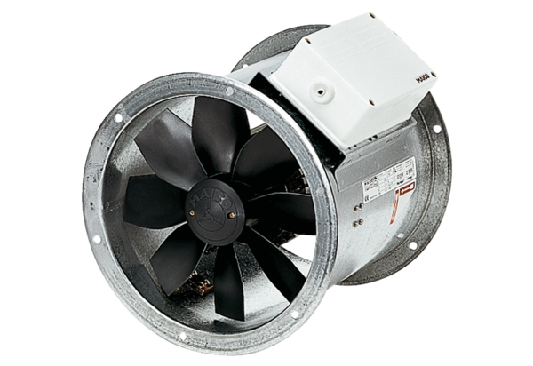Axial duct fan EZR 40/4 BPacking unit: 1 pieceRange: C
Article number: 0086.0009Manufacturer: MAICO

