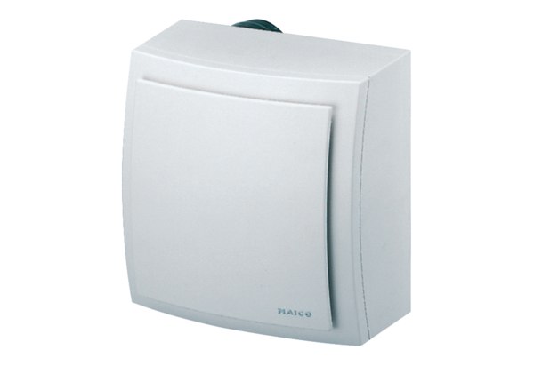Surface-mounted fan ER-AP 100 VZPacking unit: 1 pieceRange: B
Article number: 0084.0171Manufacturer: MAICO

