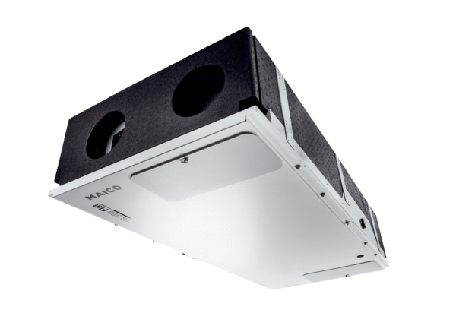Centralised ventilation unit WS 300 Flat BRPacking unit: 1 pieceRange: K
Article number: 0095.0142Manufacturer: MAICO

