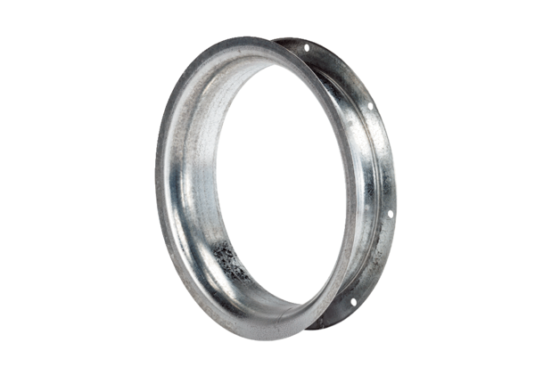Suction nozzle AD 25Packing unit: 1 pieceRange: C
Article number: 0180.0620Manufacturer: MAICO

