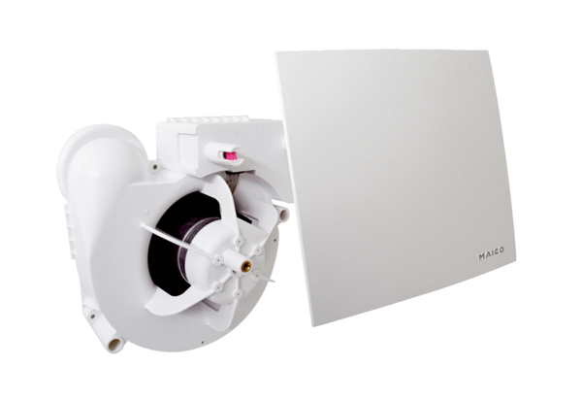Fan insert ER 100 EHPacking unit: 1 pieceRange:
Article number: 0084.0384Manufacturer: MAICO

