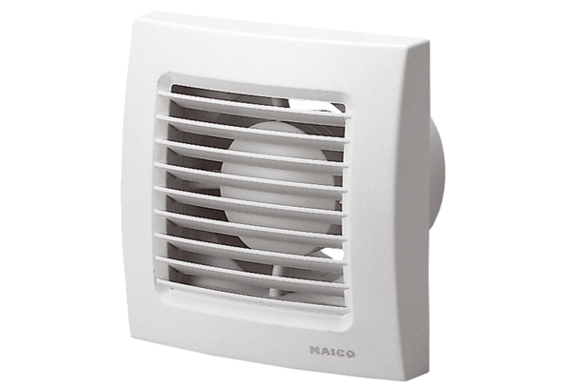Small room fan ECA 100 24 VPacking unit: 1 pieceRange: A
Article number: 0084.0018Manufacturer: MAICO

