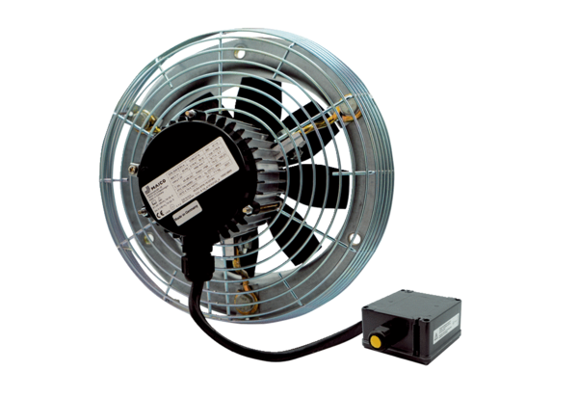Axial wall fan DZS 35/2 B Ex ePacking unit: 1 pieceRange: C
Article number: 0094.0125Manufacturer: MAICO

