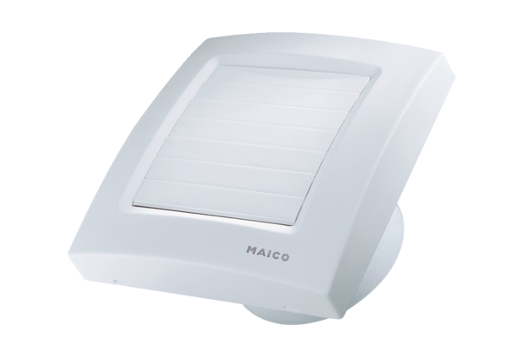Small room fan ECA 120 KVZPacking unit: 1 pieceRange: A
Article number: 0084.0010Manufacturer: MAICO

