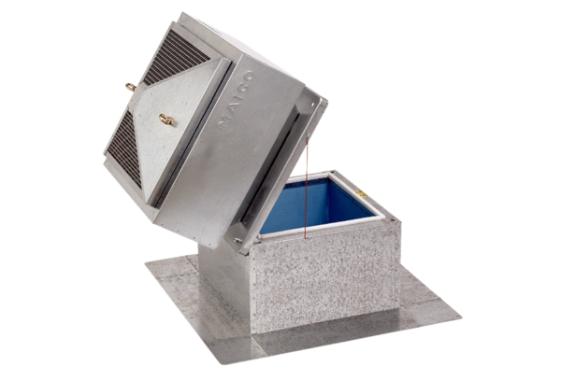Roof socket for flat roofs, tiltable SOK 18Packing unit: 1 pieceRange: C
Article number: 0093.1030Manufacturer: MAICO

