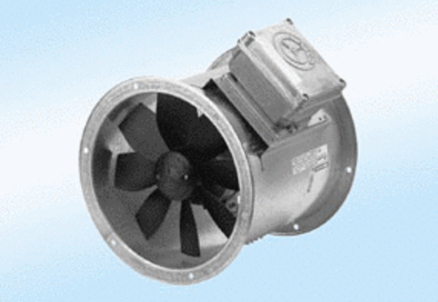Axial duct fan DZR 20/2 A-ExPacking unit: 1 pieceRange: C
Article number: 0086.0756Manufacturer: MAICO

