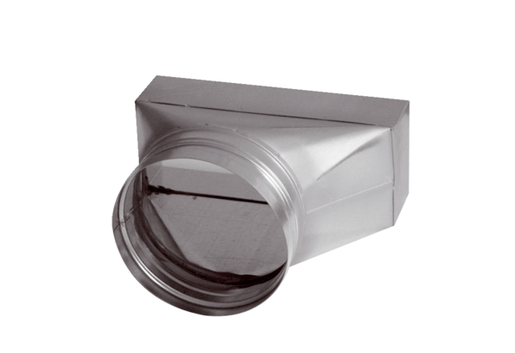Intermediate piece, asymmetric USAN70/170/100Packing unit: 1 pieceRange: K
Article number: 0055.0663Manufacturer: MAICO

