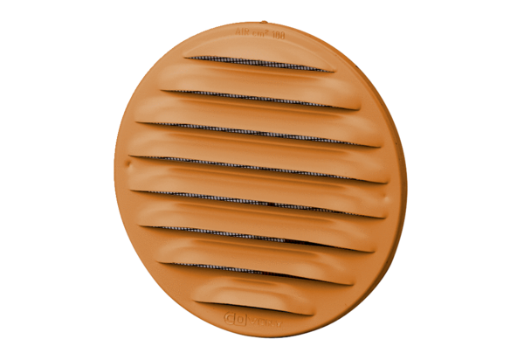External grille MGR 80/125 cuPacking unit: 1 pieceRange: K
Article number: 0078.0035Manufacturer: MAICO

