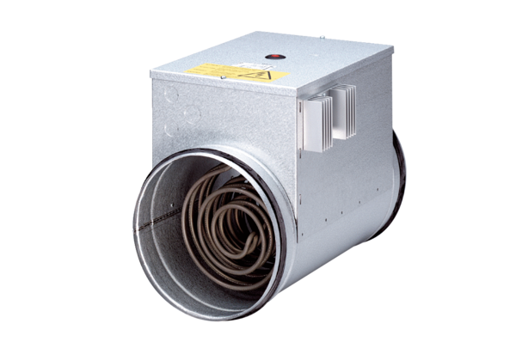Electrical air heater with controller DRH 31-12 RPacking unit: 1 pieceRange: C
Article number: 0082.0146Manufacturer: MAICO

