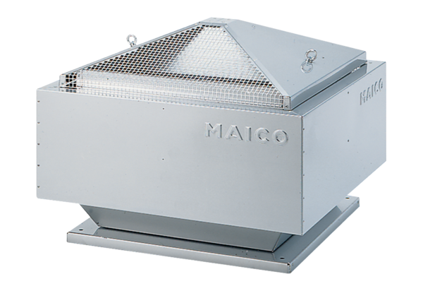Centrifugal roof fan DRD 31/64 BPacking unit: 1 pieceRange: C
Article number: 0087.0151Manufacturer: MAICO

