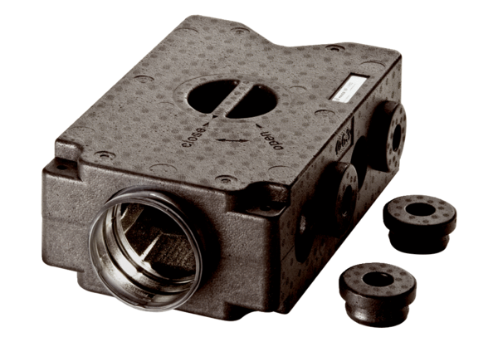Air distributor made of plastic, 8-way MF-V63Packing unit: 1 pieceRange: K
Article number: 0059.0970Manufacturer: MAICO

