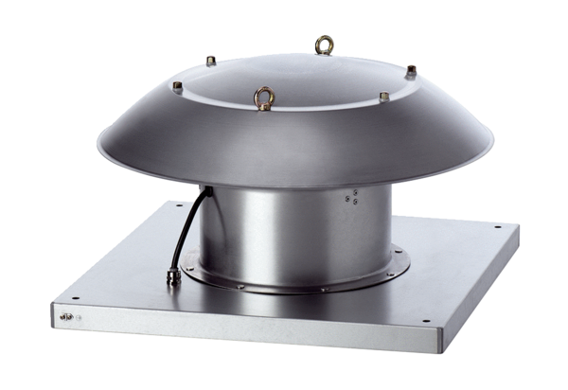Axial roof fan DZD 25/4 B Ex ePacking unit: 1 pieceRange: C
Article number: 0087.0796Manufacturer: MAICO

