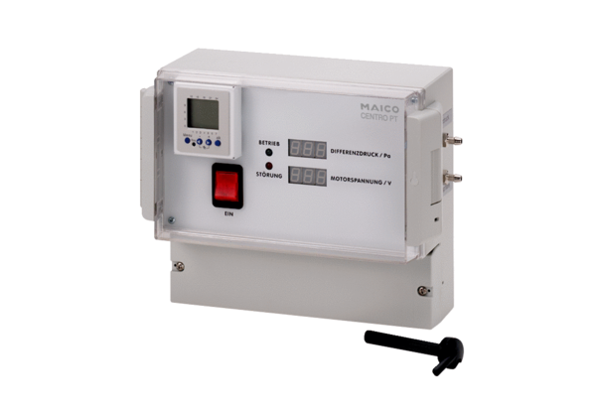Pressure controller Centro-PTPacking unit: 1 pieceRange: B
Article number: 0157.0399Manufacturer: MAICO

