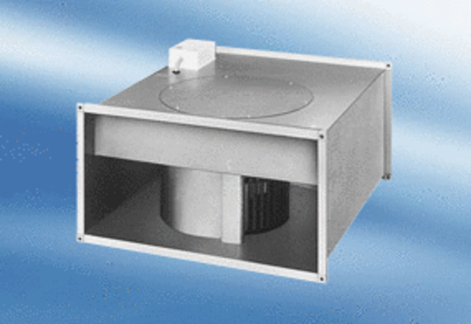Channel fan EPK 28/4 APacking unit: 1 pieceRange:
Article number: 0086.0615Manufacturer: MAICO

