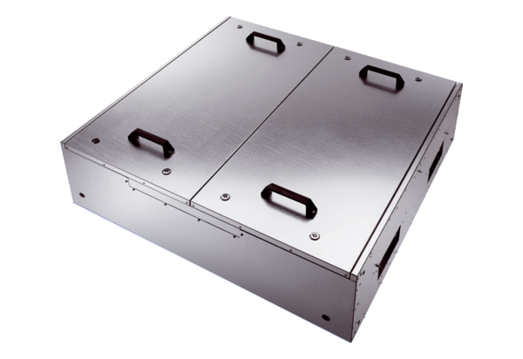Sound-insulated ventilation box KFD 6030-APacking unit: 1 pieceRange: K
Article number: 0080.0957Manufacturer: MAICO

