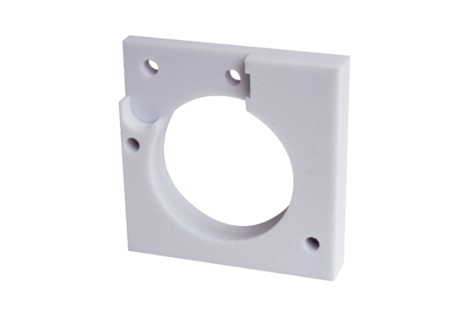Sound-absorbing element ER-SE APPacking unit: 1 pieceRange: B
Article number: 0192.0679Manufacturer: MAICO

