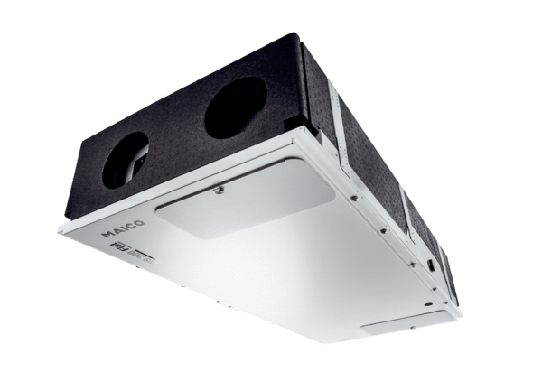Centralised ventilation unit WS 300 Flat KBLPacking unit: 1 pieceRange: K
Article number: 0095.0145Manufacturer: MAICO

