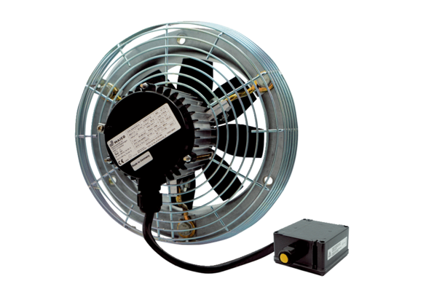Axial wall fan DZS 35/4 B Ex ePacking unit: 1 pieceRange: C
Article number: 0094.0124Manufacturer: MAICO

