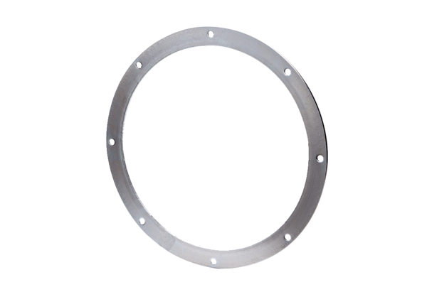Counter flange GF 35Packing unit: 1 pieceRange: C
Article number: 0056.0005Manufacturer: MAICO

