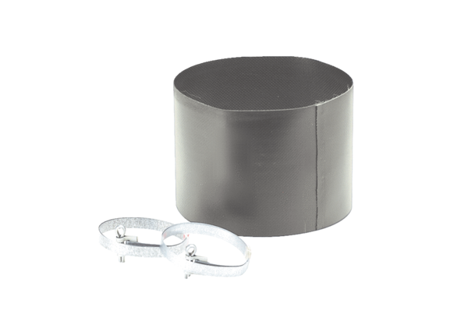Flexible cuff ELM 28Packing unit: 1 pieceRange: C
Article number: 0092.0120Manufacturer: MAICO

