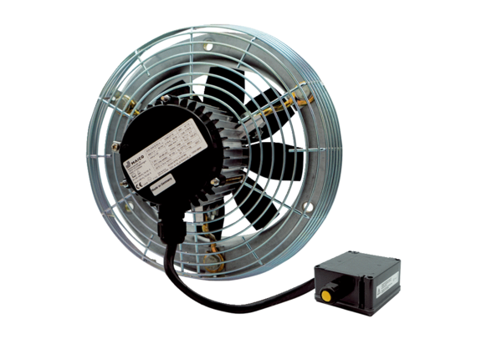Axial wall fan DZS 30/6 B Ex ePacking unit: 1 pieceRange: C
Article number: 0094.0120Manufacturer: MAICO

