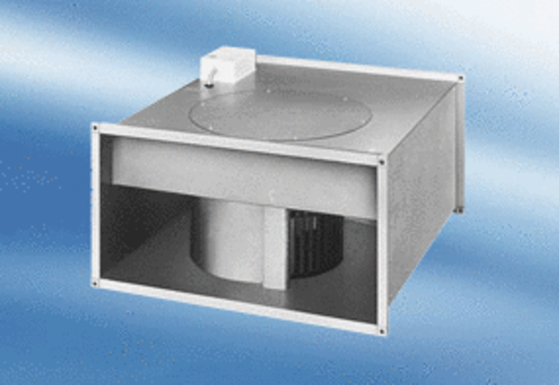Channel fan EPK 22/6 APacking unit: 1 pieceRange:
Article number: 0086.0610Manufacturer: MAICO

