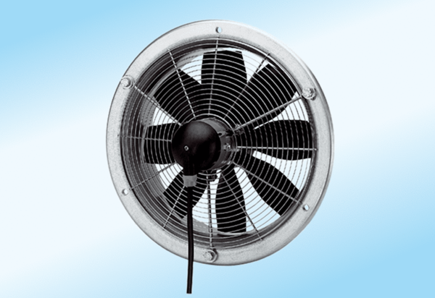Axial wall fan DZS 35/2 A-ExPacking unit: 1 pieceRange: C
Article number: 0094.0110Manufacturer: MAICO

