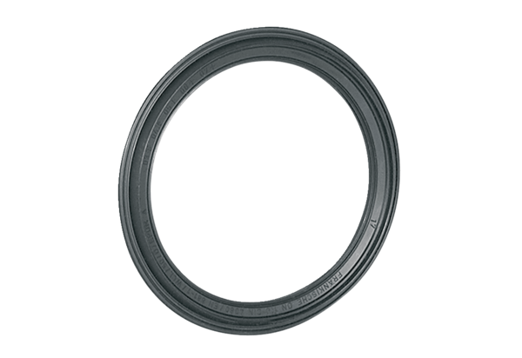Sealing ring MF-FDR90Packing unit: 10 piecesRange: K
Article number: 0175.0263Manufacturer: MAICO

