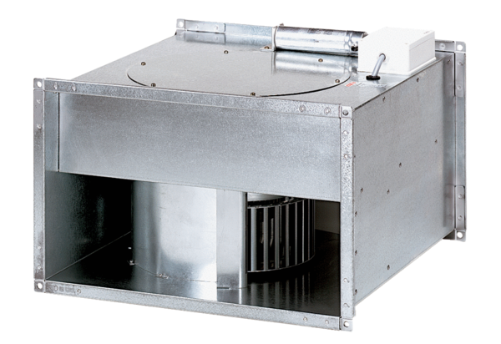Channel fan DPK 28/4 BPacking unit: 1 pieceRange: D
Article number: 0086.0665Manufacturer: MAICO

