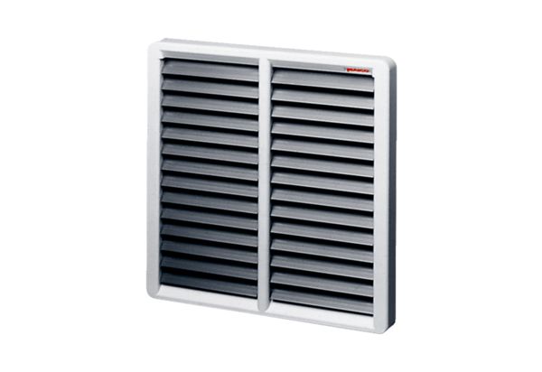Shutter AS 60Packing unit: 1 pieceRange: C
Article number: 0151.0337Manufacturer: MAICO

