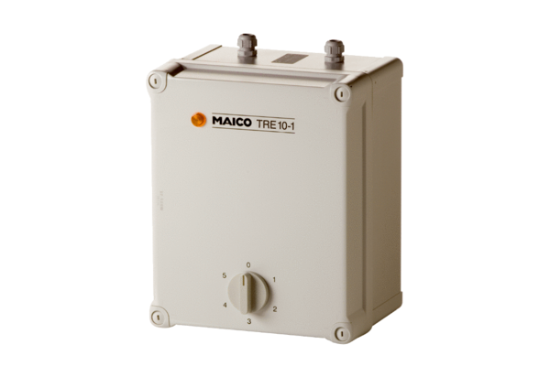5-step transformer TRE 10-1Packing unit: 1 pieceRange: C
Article number: 0157.1230Manufacturer: MAICO

