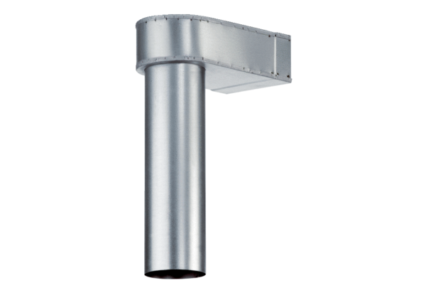Bracket MF-WL125 80/200Packing unit: 1 pieceRange: K
Article number: 0018.0531Manufacturer: MAICO

