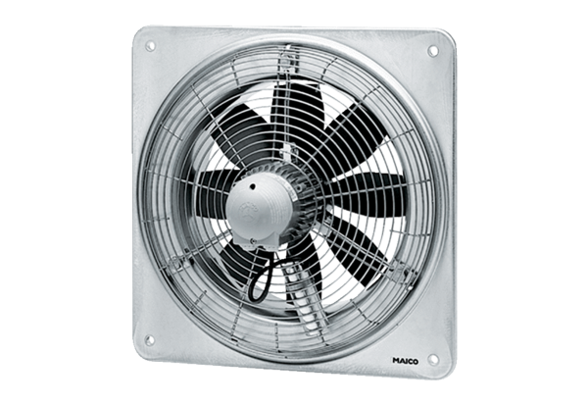Axial wall fan DZQ 40/6 BPacking unit: 1 pieceRange: C
Article number: 0083.0126Manufacturer: MAICO

