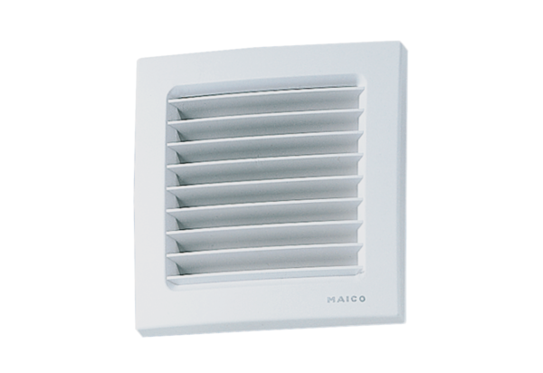Internal grille ESG 10/2Packing unit: 1 pieceRange: A
Article number: 0059.0947Manufacturer: MAICO

