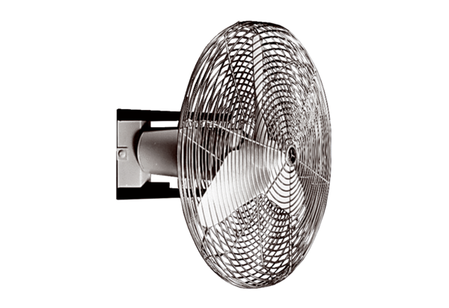ECO 40 DPacking unit: 1 pieceRange: C
Article number: 0088.0014Manufacturer: MAICO

