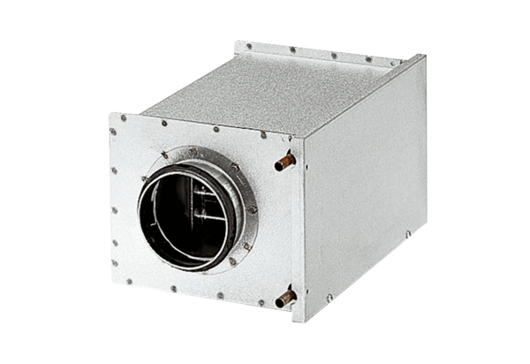Water air heater WRH 40-9Packing unit: 1 pieceRange: C
Article number: 0082.0122Manufacturer: MAICO

