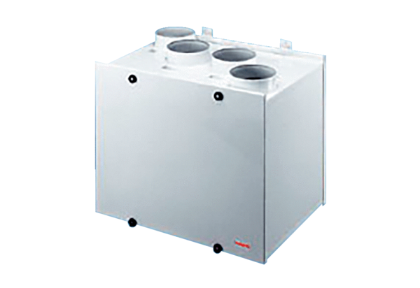Aeronom room air system WRG300Packing unit: 1 pieceRange:
Article number: 0082.0037Manufacturer: MAICO

