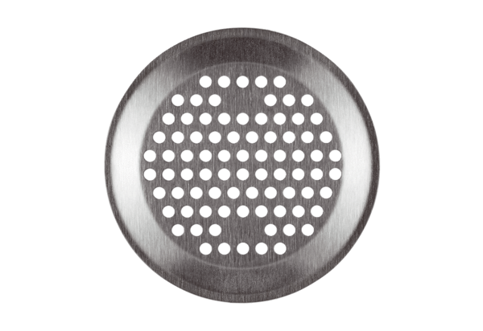Wall/Ceiling grille FFS-WGBPacking unit: 1 pieceRange: K
Article number: 0055.0893Manufacturer: MAICO

