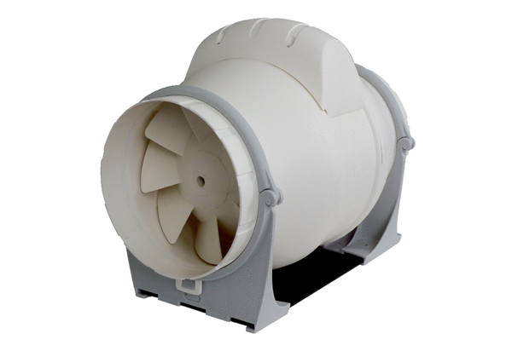Diagonal fan ERK 150Packing unit: 1 pieceRange: C
Article number: 0080.0179Manufacturer: MAICO

