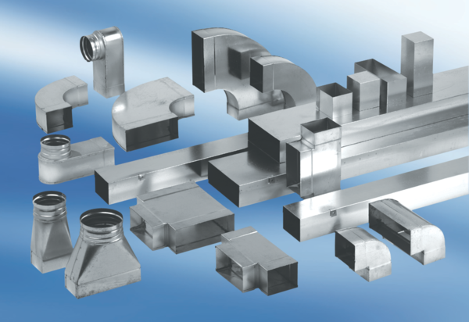40 mm channel sound absorbers with lining and attenuating linging KSDA55/110/1200Packing unit: 1 pieceRange: K
Article number: 0092.0470Manufacturer: MAICO

