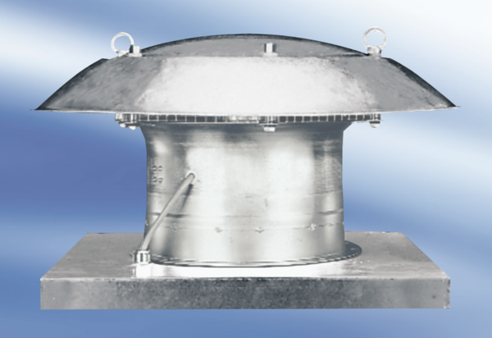Axial roof fan DZD 25/84 APacking unit: 1 pieceRange:
Article number: 0087.0430Manufacturer: MAICO

