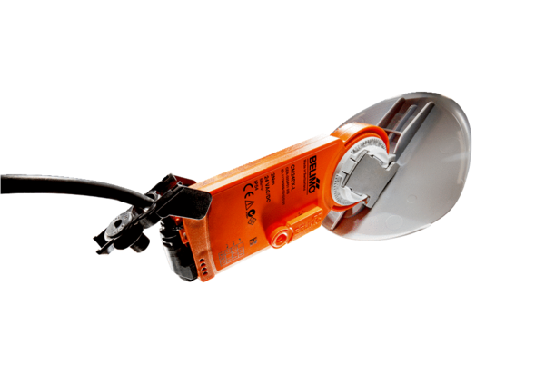Shutter drive with air damper MS 125Packing unit: 1 pieceRange: C
Article number: 0157.1232Manufacturer: MAICO

