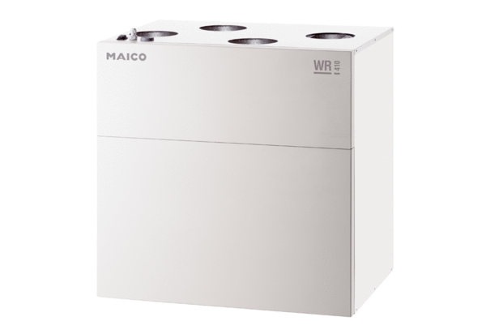Centralised ventilation unit WR 300Packing unit: 1 pieceRange: K
Article number: 0095.0078Manufacturer: MAICO

