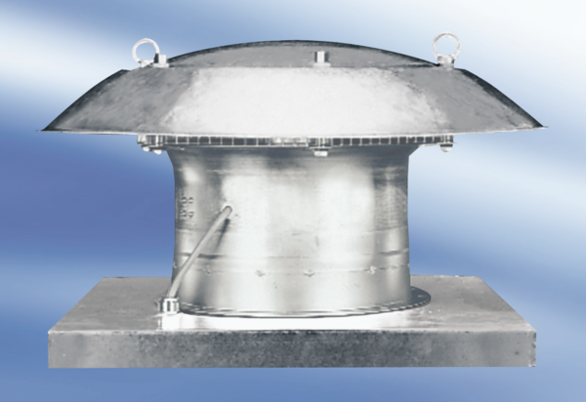Axial roof fan DZD60-6APacking unit: 1 pieceRange:
Article number: 0087.0428Manufacturer: MAICO

