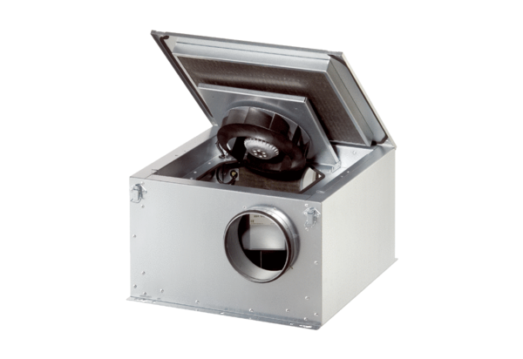Sound-insulated ventilation box ESR 16 ECPacking unit: 1 pieceRange: E
Article number: 0080.0085Manufacturer: MAICO

