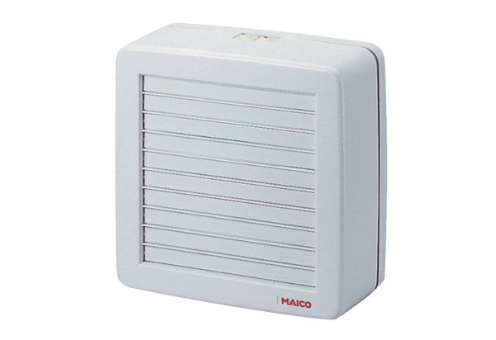Axial window fan EV 31Packing unit: 1 pieceRange: C
Article number: 0080.0820Manufacturer: MAICO

